Functional test fixture & Equipment technical specification：

Product photo | 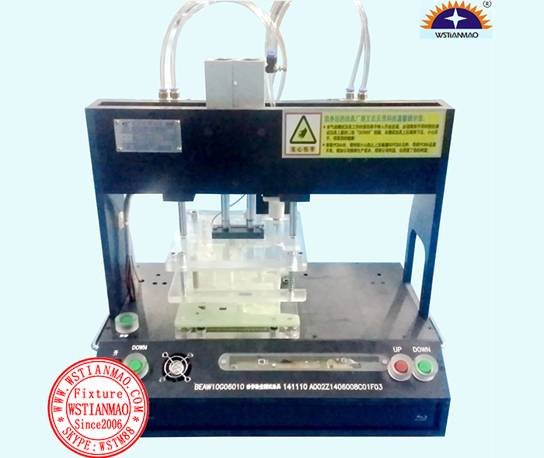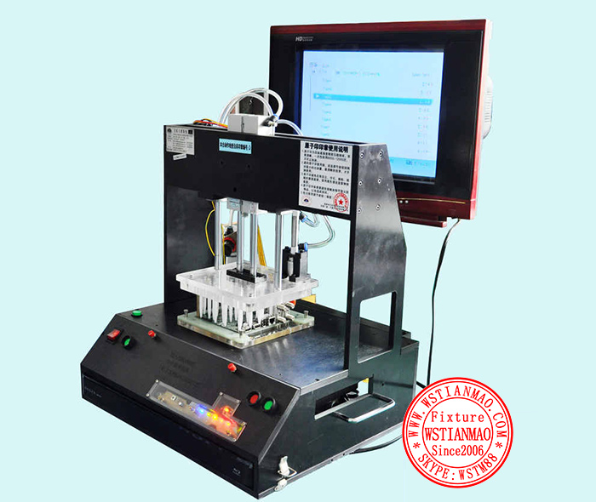
Product ID | WSTM-ECTest-001
Model No. | DVD electronics panel pneumatic function test fixture
Patent No.
keyword index | FCT; ICT; fixture; Functional Tester; Test Fixture; CJCS; testing jig; ATE
Application | Mainly used in electronic products such as DVD/EVD/VCR /PDS functional testing
Main feature | - Adopt pneumatic structure, energy saving, quickly;  - Cylinder stroke is large, convenient take put the PCB;  - Also use pallet design, ensure uniform PCB stress, deformation and component damage;  - Material USES beaverboard, antistatic acrylic sheet and aluminum alloy oxidation treatment;  - Operation panel on the text and the company sign a sculpture processing, the beauty is generous.
Advantage of WSTIANMAO | - Can perfectly solve the problem of blue high frequency signal interference.  - Can according to customer's technical requirements of non-standard custom all kinds of pneumatic functional test fixtures.
Dimensions | 1. L[ 600 ]mm×W[ 400 ]mm×H[ 800 ]mm; 2. Weight[ 35 ]KG
Operating voltage | 1. DC3.3V( ) 2. DC5V( ) 3. DC6V( ) 4. DC9V( ) 5. DC12V( ) 6. DC24V( )  7. DC36V( ) 8. DC48V( ) 9. AC110V( √ ) 10. AC220V( ) 11. AC380V( )
Production throughput | Throughput is around( 1 ) pcs/ min，Please let us know if you have any special requirements
Product category | 1. Automation equipment( ) | 2. Functional Test fixture( √ ) |  | 3. IC test fixture( ) |  | 4. Software system( )
Product category | 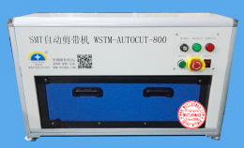 | 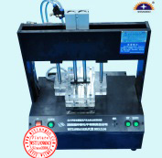 |  | 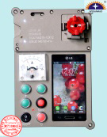 |  | 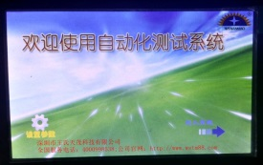
Control system design | 1. Computer-based testing system( ) |  | 2. MCU-based control system( √ ) |  | 3. PLC control system( )
Control system design | 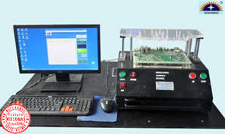 |  | 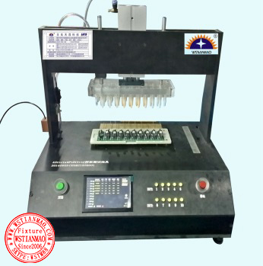 |  | 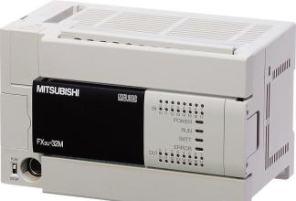
Mechanical structure | 1. Manual control( ) ; |  | 2. Electronic control( √ ) ; |  | 3. Crank and connecting rod control( )
Mechanical structure | 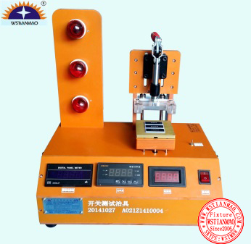 |  |  |  | 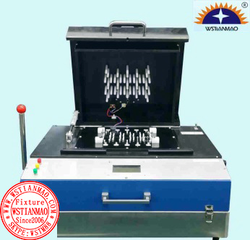
Core material classification | 1. Bakelite sheet( ) ; |  | 2. Aluminum alloy sheet( √ ) ; |  | 3. Sheet metal processing( )
Core material classification |  |  | 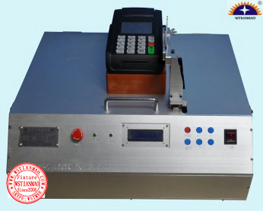 |  | 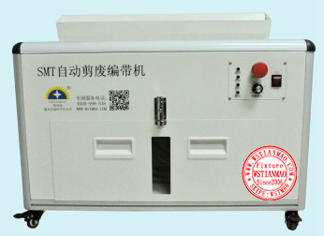
Bed of nails material | 1. Black anti-static bakelite sheet( √ ) ; |  | 2. Transparent plexiglass( ) ; |  | 4. TORLON/PEEK/PPS or other plastic materials( ) ;
Bed of nails material | 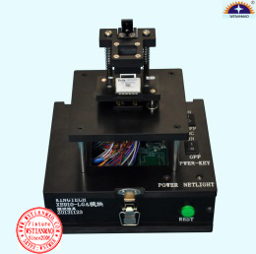 |  | 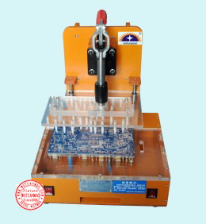 |  | 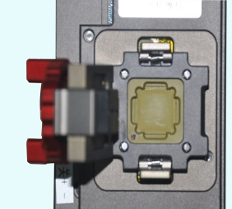
Voltmeter and ammeter selection | 1. Digital Display( ) |  | 2. Analog display( ) |  | 3. Dual display digital voltmeter and ammeter( √ )
Voltmeter and ammeter selection | 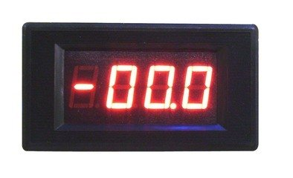 |  | 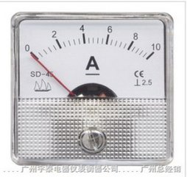 |  | 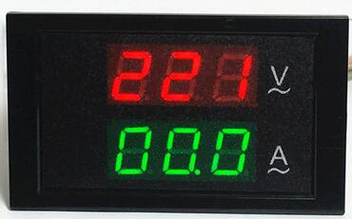
Voltmeter and ammeter selection | 1. Current testing range (default is 1A-20A), special range request( ) A～( ) A  2. Voltage testing range (default is 1V-20V), special range request( ) V～( ) V
Other Accessories | Extra accessories and design services can be provided based on the actual situation
Labeling information | 1. Product model no.(√ ) ;2. Date of manufacture(√) ; 3. WSTIANMAO's product ID( √ ) ; 4. WSTIANMAO's company nameplate( √ ) ; 5. Special requirements( )
Required documentation | 1. PCB board( ) ; 2. PCBA board(√) ; 3. PCB GERBER/CAD( √ ) ; 4. BOM( √ ) ;  5. Wiring diagram( √ ); 6. CAD drawings produced by the customer( ); 7. Special technical requirements( √ ) ;
Special requirements
Remark | 1. Please insert a tick symbol √ or a cross symbol × in a bracket [ ] ;  2. Please put a number in a bracket [ ];
Test probes | WSTIANMAO mainly use INGUN test probes which are 100% made in Germany. Please visit www.ingun.com to get more information. If you want to select other brand of test probes, please fill in your special requirement in field of "Special requirements".  

