Solder Pallet Technical Specification:
Product photo | 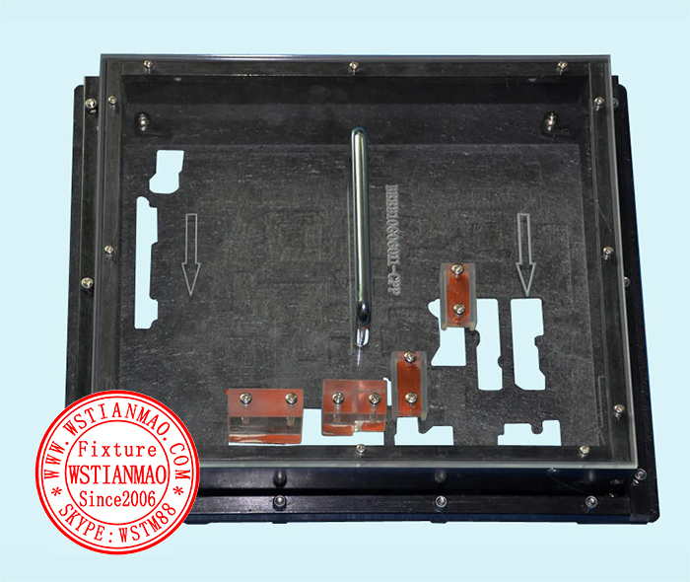
Model no.
Patent no.
keyword index
Application
Pallet ID | DIP-solder pallet-007
Pallet Name | The solder pallet of Synthetic stone carbon fiber board for wave-soldering
Main feature | static-free ; heat-resisting material ; No deformation ; Long service life;  Prevent plug-in components to float high technology
Surface treatment | Select: 1. Require（ ）; 2. Not Require（ √ ）;  Process category:  1. Sandblasting & anodizing process（ ）; 2. Without sandblasting & anodizing process（ ）; 3. Teflon anodizing process（ ）; 4. Hard anodizing process（ ）  Anodizing Color:  1. Original color（ ）2. Black color（ ）3. Green color （ ） 4. Pale yellow color（ ）
Application | 1. Solder paste printer: （ ）; 2. Chip Mounter: （ ）;  3. Reflow soldering: （√ ）; 4. Positioning: （ ）
Material category | 1. Synthetic stone carbon fiber board: （ √ ）; 2. Aerospace aluminum alloy: （ ）;  3. Titanium alloy material: （ ）; 4. FR4 fiberboard material: （ √ ）  5. High-Temp silicone adhesive: （ ）; 6. High-Temp Magnet: （ ）;  7. High-Temp magnetic steel 0.06mm: （ ）
Material model | Synthetic stone carbon fiber board | BLUE: 1. CDM68.650:（ ） 2. CHP760: （ ）
Material model | Synthetic stone carbon fiber board | BLACK: 1. CDM-ESD68.910:（ √ ）2. CAS761: （ ）
Material model | Synthetic stone carbon fiber board | GRAY : 1. CDM-ESD68.940:（ ） 2. CAG762: （ ）
Material model | Aerospace aluminum alloy | 1. 7075# : （ ） 2. 6061# : （ ） 3. 5052#: （ ）
Thickness | 1. 2mm（ ）2. 3mm（ ）3. 4mm（ ）4. 5mm（ ）5. 6mm（ √ ）6. 8mm（ ）
Shape  & Dimension | 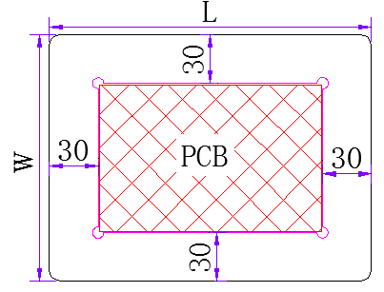 | 1. Pallet length L= PCB length (L1) + 60mm;  2. Pallet width W= PCB width (W1) + 60mm`  3. Specify pallet dimension:  Length［ ］×Height ［ ］mm  Remark: If more than one PCB board panelized in a pallet，the above calculation will be will not be applied.
Panelized method | Panelized method required in pallet design: 1. Yes: ( ); 2. No: (√ )
Panelized method | Panelized method 1: （ ）  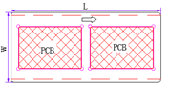 | Panelized method 2: （ ）  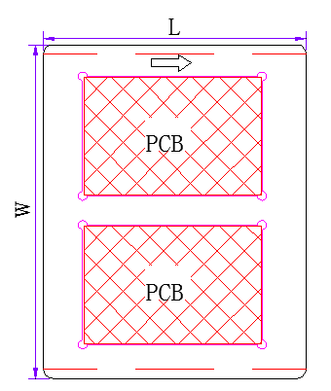 | Panelized method 3: （ ）  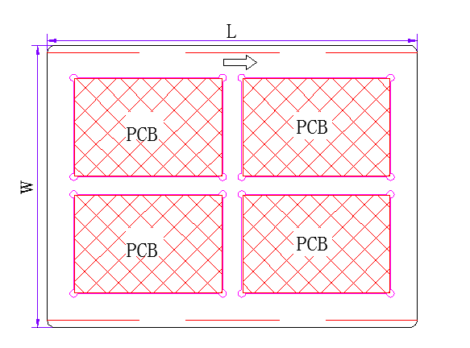
Panelized method | The width between PCBs: ［ ］mm，Default is 25mm
Panelized method | The number of PCB: ［ 1 ］ X ［ 2 ］panelized into one pallet
PCB angle on pallet | Longer side of PCB corresponding to the pallet track edge（ √ ）  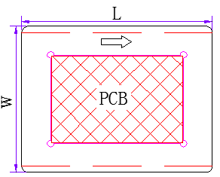 | Shorter side of PCB corresponding to the pallet track edge（ ）  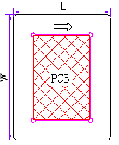 | PCB rotation angle（ ）Generally it can be 30 to 45 degrees  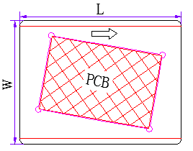
Positioning pin for holding PCB: | 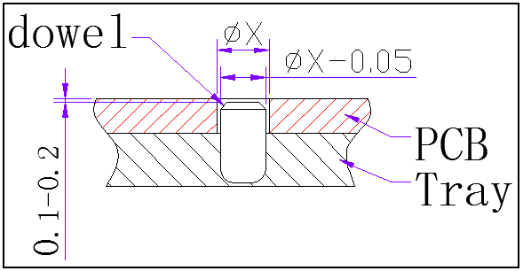 | SUS304 positioning pin，which is made by CNC machine in fine processing，ensure the PCB and positioning pin at 90 degrees
Positioning pin for holding PCB: |  | Height of positioning pin L =PCB thickness (mm) –（0.10m～0.20mm）
Positioning pin for holding PCB: |  | Positioning pin diameterфX=PCB positioning hole diameterфx–0.05mm
Pallet heat transfer  (Thermal via):  Function: prevent chip components do not melt the solder paste | TOP/BOT share，avoid chip component（ ）  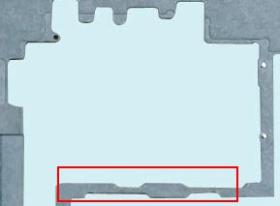 | Create thermal via at the bottom of SMD components（ ）  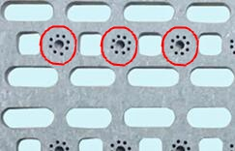 |  | Create thermal via at the open area of pallet（ ）  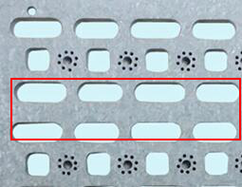
Wave solder pallet – open space requirement | PCB BOT component protection（ √ ）  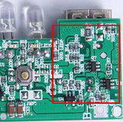 | Screw hole protection（ √ ）  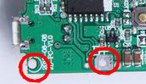 |  | Plastic connector pin protection（ √ ）  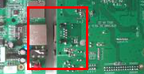
Pallet track edge dimension: | 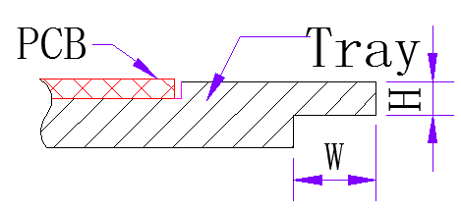 | Pallet track in the lower part of pallet (√ )  H=2mm; W=5mm  Please let us know if you have special requirements.
Pallet track edge dimension: | 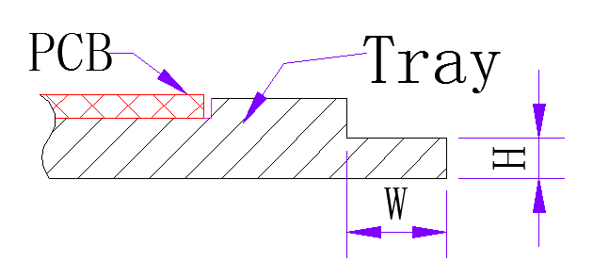 | Pallet track in the upper part of pallet :  H=2mm; W=5mm  Please let us know if you have special requirements.
PCB cavity dimension | 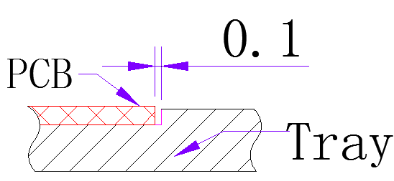 | PCB cavity dimension = PCB dimension + 0.10mm / edge
PCB cavity depth dimension | 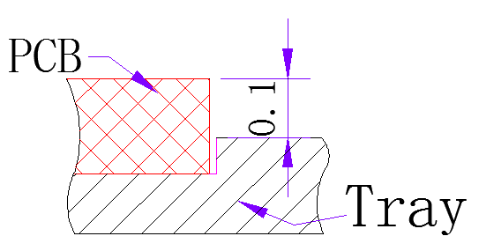 | PCB cavity depth dimension = PCB thickness – 0.10mm
The Packet hole for takeoff the PCB | 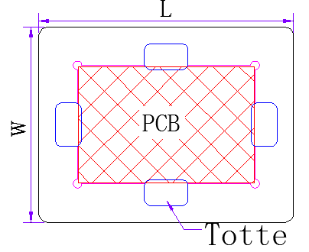 | In general, four packet hole will be provided, one for each direction  Please let us know if you have special requirements.
The holddown design | 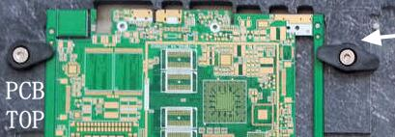 | Mainly used for SMT wave solder pallet;  It includes the following accessories: high temperature plastic holddowns, springs, screws, adhesive thread locking agent
The holddown design | 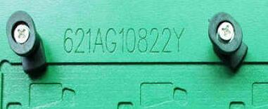 | Mainly used for wave solder pallet(√ )  It includes the following accessories: high temperature plastic holddowns, springs, screws, adhesive thread locking agent
The holddown design | 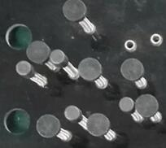 | Mainly used for wave solder pallet to prevent topside component movement throughout wave solder. (√ )  It includes the following accessories: high temperature plastic holddowns, springs, screws, adhesive thread locking agent
Design of wave solder pallet block tin bar | 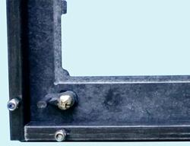 | Antistatic FR4 fiberglass board material，dimension: 10 x 10mm，  1. Black color（ √ ）; 2. white color（ ）
Design of wave solder pallet block tin bar | 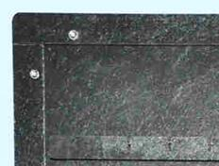 | Synthetic stone materials, dimension: 6 x 6mm，black color  ( )
Design of wave solder pallet block tin bar | 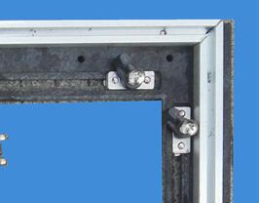 | 5052# Aluminum materials, dimension: 10mm (T) x 13mm (W)
Pallet printing information | 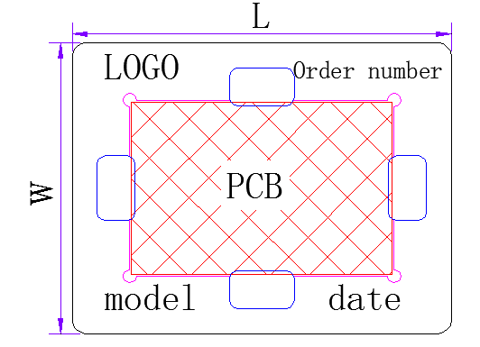 | 1. WSTIANMAO LOGO （ √ ） 2. production model （√ ）  3. Date of manufacture（ √） 4. Pallet flow arrow sign （ ）  5. Serial No. （ ） 6. CAD drawing No.（ √ ）  7. ROHS marking（ √ ） 8. ESD marking （ ）  Please let us know if you have special requirements.
Required documentation | 1. PCB board（ ）2. PCBA board（ √ ）3. PCB GERBER/CAD（ √）4. Pallet sample（ √ ） 5. CAD drawings produced by the customer（ ） 6. Special technical requirements（ ）
Production capacity | - SMT solder pallet: General processing capacity is 50 vehicles / 36 hours  - DIP solder pallet: General processing capacity is 50 pallets / 48 hours  - The above is the processing time within the factory and the logistics & freight time is according to the logistics company
Special requirements | 1. Prevent plug-in components to float high technology  2. To prevent the pollution flux
Remark | 1. Please insert a tick symbol “√ ” or a cross symbol“ × ”in a bracket （ ）;  2. Please put a number in a bracket ［ ］;
Technical parameters of synthetic material | All the technical parameters of this material is provided by synthetic materials manufacturers, WSTIANMAO does not have the right to decide.
Technical parameters of synthetic material
  （Vonroll Isola） Synthetic fiber technology parameters
  Product number | CDM 68.650 | CDM-ESD 68.910 | CDM-ESD 68.940
  Color | blue | black | gray
  ESD | no | yes | yes
  Light-reflecting | no | no | yes
  Density g/cm³ | 1.90 | 1.90 | 1.90
  standard working temperature℃ | 360 | 360 | 360
  surface impedance ohms | ------ | 10⁵ ～10⁹ | 10⁵～10⁹
  Panel size (mm) | 980×1335 | 1220×1950 | 1335×2350
  thickness of plate (mm) | 3∕4 ∕ 5 ∕ 6 ∕ 8 ∕ 10 ∕ 12 ∕ 14
  platness tolerance (mm) | ± 0.10
  （Rochling Durostone） Synthetic fiber technology parameters
  Product number | CHP 760 | CAS 761 | CAG 762
  Color | blue | black | gray
  ESD | no | yes | yes
  Light-reflecting | no | no | yes
  Density g/cm³ | 1.85 | 1.85 | 1.85
  standard working temperature ℃ | 300 | 300 | 300
  surface impedance ohms | ------ | 10⁵ ～10⁸ | 10⁵～10⁸
  Panel size (mm) | 1220×2440
  thickness of plate (mm) | 3∕4 ∕ 5 ∕ 6 ∕ 8 ∕ 10 ∕ 12
  platness tolerance (mm) | ± 0.10

